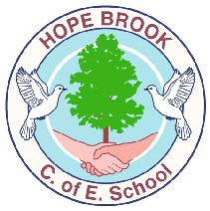  Who should I talk to if I would like to discuss my child’s learning?  - Class Teacher  - SENDCo (Mrs Marshall)  - Family Support Worker and ELSA (Mrs Southwell)  - Acting Head Teacher (Mrs Marks)  Where else can I find information?  https://www.hopebrook.co.uk/website/additional_needs_-_meeting_the_diverse_needs_of_our_children/311739  www.glosfamiliesdirectory.org.uk  www.familylives.org.uk  www.ghc.nhs.uk  www.sendiassglos.org.uk  What happens if I am not happy with the provision my child is offered?  We strive to ensure that this does not happen but if it should then please contact our SEND Governor, Revd Lara Bloom, via the school Business Manager (admin@hopebrook.gloucs.sch.uk) who will be happy to discuss your concerns and plan a way forwards to ensure successful outcomes are achieved for your child. Further advice can be found from the organisations listed above. | Hope Brook Church of England  Primary School  Information Report  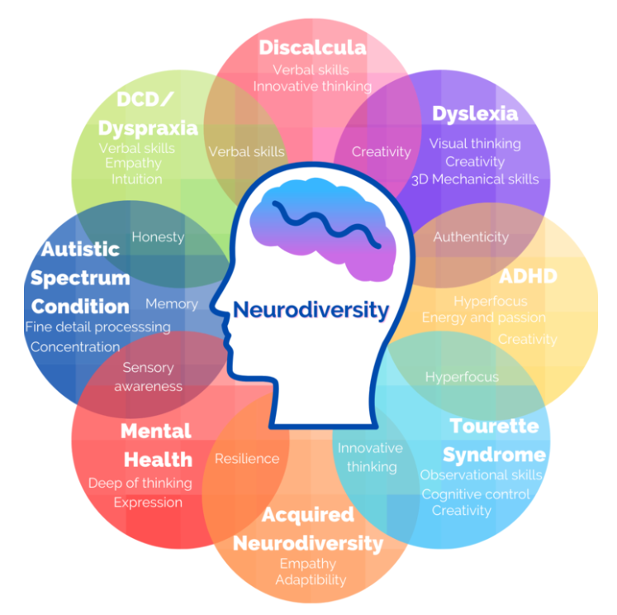  Longhope Gloucestershire GL17 0LL
Growing together with God’s love to bring hope to the world.  At Hope Brook C of E Primary School, we want all members of the school community to continually grow in our learning and our understanding of ourselves, each other and the wider world. We seek to do this together as an inclusive community were everyone is welcomed, valued and nurtured. As a Church of England School, we are inspired by the message and actions of Jesus as he shared hope and love with all he met and spoke about the Kingdom of God. Following this example, we aim to bring hope by being salt and light in our community and the wider world.  All children experience quality first teaching from all members of the teaching team. However, at times in a child’s development they may require additional opportunities, accommodations or adjustments to their learning experiences in order to achieve their fullest potential.  Examples of additional opportunities: - Small group withdrawal support - Individualised programmes - One to One Tuition with a teacher or TA Examples of accommodations or adjustments: - Small group in class support - Working partners - Use of technology - Desk top: work stations, task boards, communication cards, word mats, wobble cushions, reading guides, coloured overlays | How is my child’s learning monitored?  Children are assessed by their teaching team in a variety of ways. These include:  - Continual Classroom Observations (Daily)  - Formative Assessments (ongoing)  - Summative Assessments (Weekly/Termly)  - My Plan or My Plan+ (My Assessment)  - Education, Health and Care Plans  Within our teaching team we offer the following areas of expertise:  - Mental Health - Behaviour - Emotional Well Being - ELSA - Communication and Interaction - Social Skills - Listening and Attention Skills - Motor Skills - EYFS (L7) - Certificate in Specific Learning Difficulties/Dyslexia (L7) - Phonics - Year 5 and 6 Maths  Sometimes the advice of other professional is requested, to further develop our understanding of your child’s needs. These may include:  - Occupational Therapy - Speech Therapy - Advisory Teaching Service: - Educational Psychology - School Nurse - Physiotherapy Service - Family Support Worker - Early Help Team - Community Paediatrician - Children and Young People Service (CYPS) - Toucan Play Therapy - TIC+ - Social Care - Child Behaviour and Parenting Courses - Winston’s Wish - Forest Pulse - Young Carers - Art Space Specialist Support - Play Rangers (Holiday Activities) - PEAK

