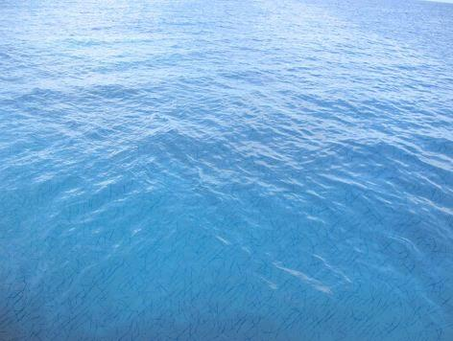

**Christianity**

**How should we care for others and the world and why does it matter?**

Names and location of the oceans and seas

Features of the undersea landscape

Create own maps using geographical language

Weight of materials

Comparing ocean widths

Pictogram of boat power

Differences between 2D and 3D shapes

Information books Lighthouse keeper story Classic poetry

2D and 3D images of Atlantic animals

Seascape collage using watercolours and salt

Exploring sounds from the sea and making up sequence to retell a story using music

Seaside habitats What floats and what sinks?

Pacific Ocean Food Chains Camouflage

Effect waves have on the coastlines

Effect waves have on the coast

Design and build a boat

**Computing**

**We are Zoologists!**

**P.E.**

**Striking and fielding**

**Athletics**

OVER THE OCEAN