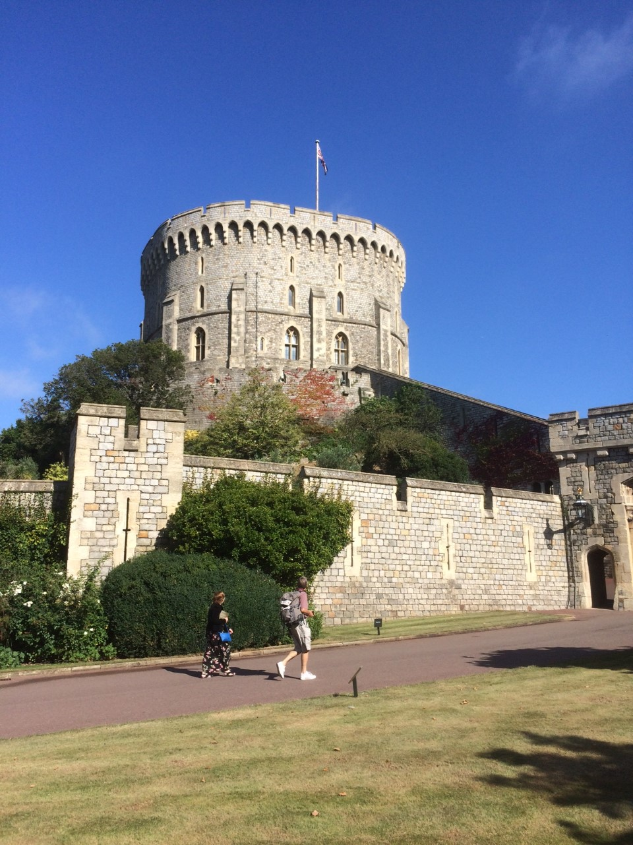

PE:

Y4/5 Swimming and Football.

Science:

Forces: Pulleys, gears and levers.

French:

Ma Famille.

RE:

Why do some people believe in God and some people not?