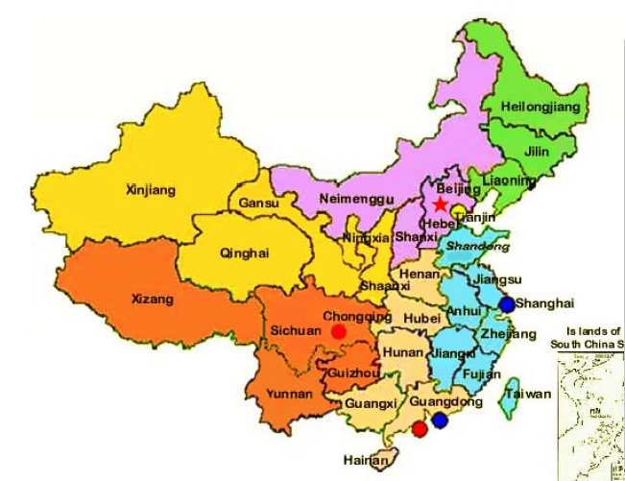

**Outdoor learning**

Building the Great Wall of China!

Literacy trail/stories nature walks, dinosaur mud swamp and more!

**Maths**

Does money grow on trees? (old Chinese legend)

Relate school life and learning in China to England – routines, events, simple counting to 10.

Use appropriate measurements when cooking Chinese food

Draw clock faces to show time in Enland and the time in China.

Draw pictures of what you would be doing and what a nChinese child would be doing at each hour of the day.

RE:

Who is Jewish and how do they live?

Celebrating Shabbat

PHSE:

World of drugs

The role of medicine in promoting, improving and sustaining health.

***English:***

Handwriting – joining upper case and lower case letters

Comprehension

Simple Grammar –recognising and using correct vocabulary and punctuation

Role–play – Chinese palace

Story writing – Fantasy writing

Write a letter

Church visit

Making and eating Chinese food in our very own restaurant!

**Science:**

**Changing materials – water –ice –steam –melting chocolate, using a thermometer**

Chinese Take-Away!