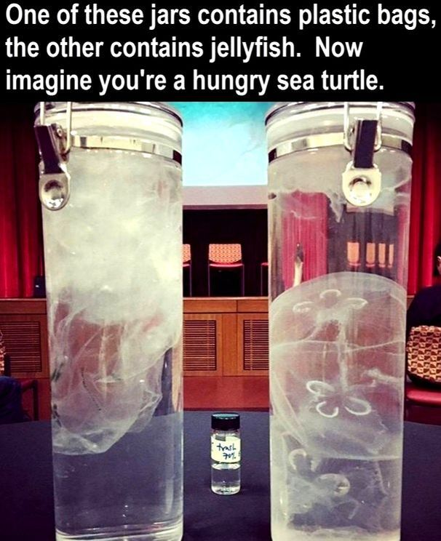
Can you see why Duffy was so confused?

