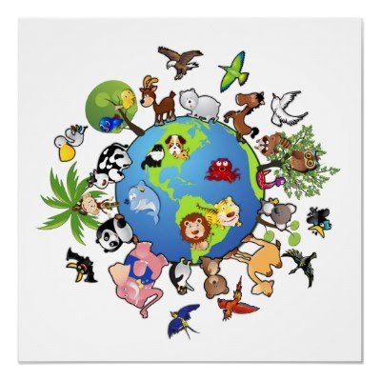

**Amazing Animals**

**The main aim of this topic is to explore the different animals in the world:**

Where they live

What they eat

What they look like and how they move

**Science:** Identify and name amphibians, reptiles, birds and mammals including pets.

Learn which animals are carnivores, omnivores and herbivores

Describe and explore the structure of a range of animals.

Learn about and observe the lifecycle of a butterfly and a frog.

**ICT:** use technology purposefully to create, organise, store, manipulate and retrieve digital content.

understand what algorithms are; how they are implemented as programs on digital devices; and that programs execute by following precise and unambiguous instructions

create and debug simple programs

use logical reasoning to predict the behaviour of simple programs.

**PE:** doing the animal bop-moving like animals, creating dance routines and responding to music through dance. Throwing a small ball, using a bat and racket. Practicing our running, jumping and movement skills in preparation for sports day.

**Maths:**  Multiplication and division.

Fractions.

Geometry -position and direction.

Place value within 100

Money

Time

**English:** We will be using our imaginations to write a story about an animal that could be hiding in the garden, inspired by ‘There’s A Tiger in the Garden’ by Lizzy Stewart.

Writing animal riddles.

Writing non-fiction texts about animals.

Animal poems using –ed –er and –est suffixes (louder, loudest, charged)

Knowing and using capital letters, full stops and beginning to use question marks and exclamation marks.

Practicing letter formation in handwriting lessons.

**Art:** Study of Matisse ‘The Snail’ picture- making a response in collage and printing.

Animal printing. Making animals using a range of media.

Creating an African animal sunset using a watercolour wash.

**As musicians** explore various percussion instruments to accompany animal songs

**Personal, Social and Emotional Development:** We will be building our independence and resilience.

Knowing how to keep ourselves safe and how our bodies grow and change.

**RE:** What places are special and why. What times/stories are special

**This terms values** are Creativity and Trust.