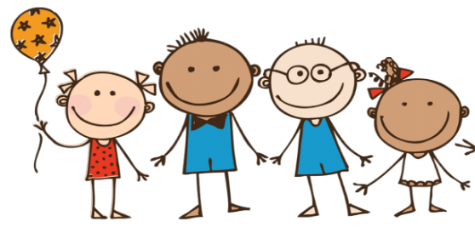

**Literacy**

Joining in with stories and rhymes.

Discussing new vocabulary. Considering how a story might end.

Explain what is happening in a story.

Phonics and tricky words.

Handwriting, correct formation of letters.

**Mathematics**

**Numbers: Yr1-**developing knowledge of place value by sorting objects into groups, counting and representing objects and numbers. Practicing different ways of counting, finding one more/less and ordering/comparing numbers.

**Yr R-**developing a strong grounding in number, sorting and comparing amounts. Comparing size, mass, capacity and exploring pattern.

**Values:** We will be focusing on a value each half term, reflecting on its different meanings. Our focus for this term will be Respect.

**Autumn term 1 Reception & Yr1**

**Changes**

We will be exploring changes in our world.

**Communication and language**

Looking at the speaker helps me to listen to the speaker.

It’s time to ask questions!

Learning to ask what does….mean?

Learn new vocabulary through stories and rhymes.

Use new words and discuss their meanings.

**Things to remember this term:**

water bottle

Book bag

PE kit

Outdoor clothes for Friday

**Please label all clothes and items brought into school.**

**Understanding the World**

We will be thinking about how we have changed and what changes have happened in our lives?

Creating a visual timeline.

Explore how our grandparent’s lives have changed.

Investigate changes in where we live.

Develop an awareness of the past, using common words and phrases relating to the passing of time.

Identify and name the basic parts of the human body.

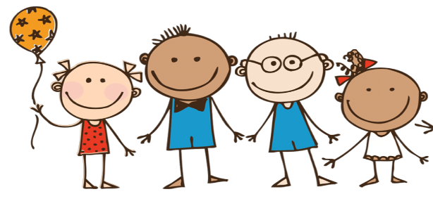

**Autumn term 1 Reception & Yr1**

**Changes**

We will be exploring changes in our world.

**RE-Being special: where do we belong?**

How do we show respect for one another?

How do we show love/how do I know I am loved?

Who do you care about? How do we show care/how do I know I am cared for?

How do you know what people are feeling?

How do we show people they are welcome?

What things can we do better together rather than on our own?

Where do you belong? How do you know you belong?

What makes us feel special about being welcomed into a group of people?

**Physical development**

We will have plenty of opportunity to

develop our fine motor skills by

playing with: playdough, threading, big chalks using tweezers, practising using scissors etc.

**PE will be on Thursdays**. This term we will be travelling and balancing in different ways, copying sequences, actions and repeating them.

**Outdoor Learning will be on Fridays**.

**Expressive Arts and Design**

Let’s create a new colour.

Name primary and secondary colours.

How do we look? Create a picture of themselves using a range of materials and mediums.

Sort, group and weave fabrics and threads.

Singing nursery rhymes and action songs.

Listening and responding to different styles of music.

Improvising and learning to play instruments.

**Personal, social and emotional development**

Develop relationships with our teacher Mrs Stanton and the other adults that help us in school.

Talk about ourselves, families and important people in our lives - how we are the same/different.

Identify and describe a range of feelings/emotions, ways to change feelings and who to go to for help.