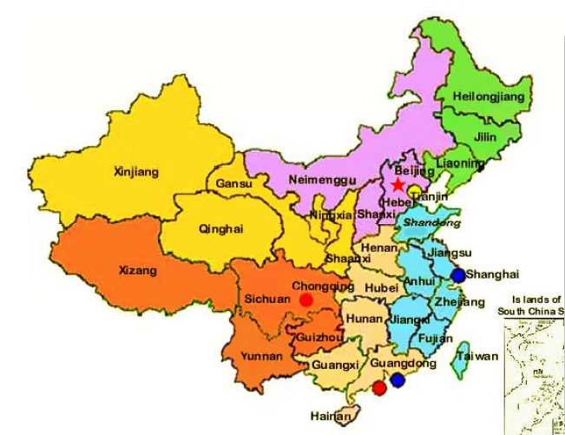

Chinese Take-Away!

**Science: Materials**

Identify different types of materials

Sort and group according to properties

Test materials to find the most suitable for an umbrella

RE:

Who is Jewish and how do they live?

Celebrating Shabbat

**Maths**

Does money grow on trees? (old Chinese legend)

Relate school life and learning in China to England – routines, events, simple counting to 10.

Use appropriate measurements when cooking Chinese food

Draw clock faces to show time in Enland and the time in China.

Draw pictures of what you would be doing and what a Chinese child would be doing at each hour of the day.

***English:***

Handwriting – joining upper case and lower case letters

Comprehension

Simple Grammar

Role–play – Chinese palace

Story writing – Chinese New Year

Facts about China

Rhymes from another culture

**Outdoor learning**

Building the Great Wall of China!

Literacy trail/stories nature walks, dinosaur mud swamp and more!

Identify

PHSE:

World of drugs

The role of medicine in promoting, improving and sustaining health.

Church visit

Making and eating Chinese food in our very own restaurant!