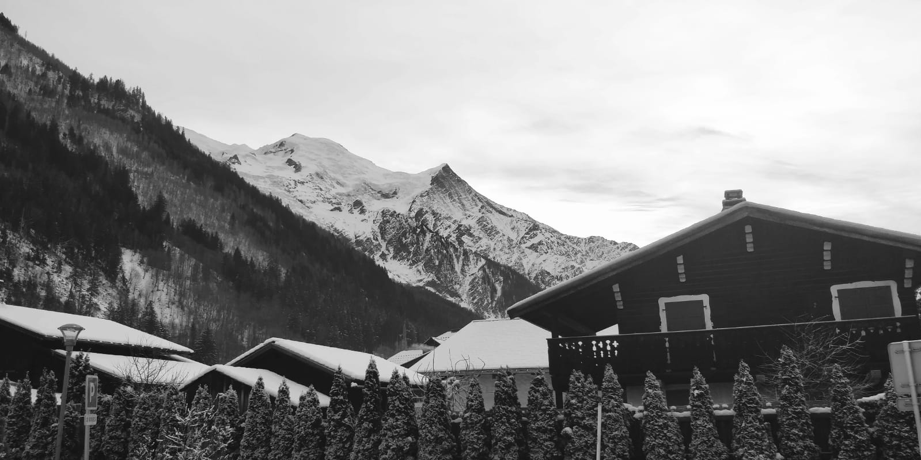

**RE:**

For Christians, when Jesus left, what was the impact of Pentecost?

**Science:**

Living Things and Their Habitats.

**TRIPS:** There will not be any this term due to Cov-id 19 restrictions.

**PE:**  Football and Dance;

Daily Mile;

Mindfulness.