**Literacy**

**Reading**: considering characters, retelling stories, reinforcing Phase 2+3 sounds and tricky words before moving on to Phase 4

**Writing**: constructing and then writing phonically spelt words and then sentences

**Mathematics**

**Numbers:** representing numbers, zero, more or less, counting, adding and taking away

**Shape, Space and Measure:** shapes, pattern, time, length, height, mass, capacity

This little light of mine, I’m gonna to let it shine!

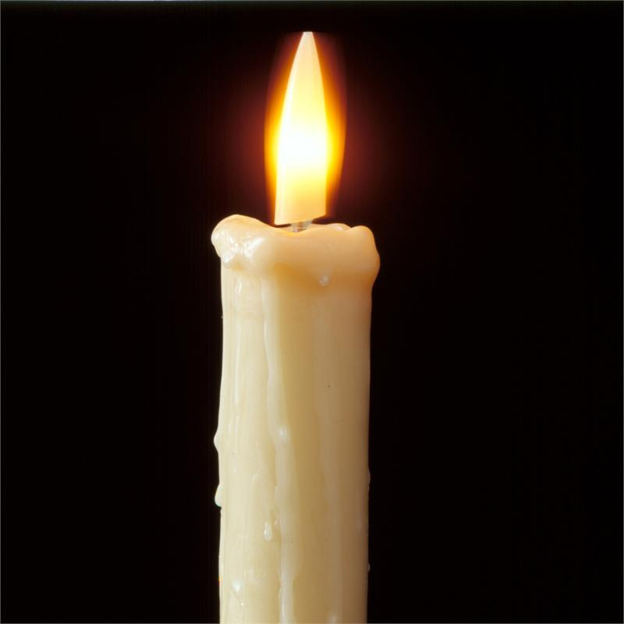

Celebrations

Twinkle twinkle little star

**RE**

What makes somewhere special?

Twit twoo!

Celebrations;

a time to share

a time to think

a time of hope

**Communication and Language**

Using interesting words

.

.

**Physical Development**

PE: Skip to the beat

Games: it’s catching so kick it high

Handwriting: formation just got serious

**Personal, Social and Emotional Development**

Respecting ourselves and others

Exploring consequences

This little light of mine, I’m gonna let it shine