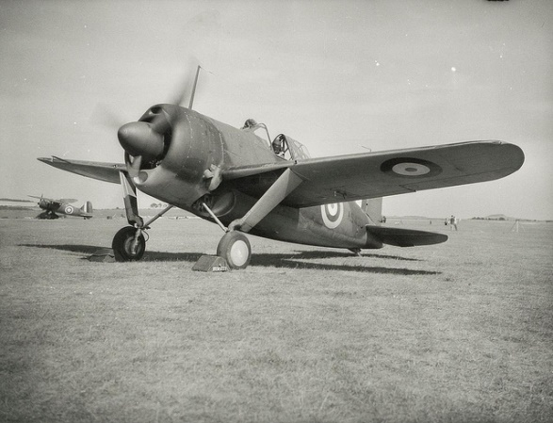

Battle of Britain

* a turning point -

**History:**

-Develop a chronologically secure knowledge and understanding of the Battle of Britain.

-Read various accounts of ‘Aerial Warfare’ from pilots who fought during the war.

-Gain historical knowledge about British and German planes that were used during World War II.

-Create a fact file about ‘The Blitz’.

- Visit to Aerospace Bristol.

**DT:**

Create own World War II plane.

**Science: Forces**

Recognise that some mechanisms including levers, pulleys and gears allow a smaller force to have a greater effect.

**Music:**

Learn a World War II song.

**PSCHE:**

**Y4** Keeping Safe/Healthy Relationships.

**Y5** Keeping Safe – online/Healthy Relationships/Caring for the Environment.

**RE:**

Why do Hindus want to be good?

Learn about key concepts Dhama and Kama. Also, learn about the Hindu daily duties.

**PE:**

Floor gymnastics/swimming/Mini Marines

**English**

Persuasive writing: create a propaganda poster.

Newspaper report: create a newspaper report based on ‘The Battle of Britain’.

Poetry: Create a poem based on World War II.

**SPAG:**

Y4 Paragraphs and possessive apostrophes of plural nouns.

Y5 Relative clauses and modal verbs.

Daily spelling practise.

**French:**

School subjects/farming/jobs.

**Art:**

Draw a World War II fighter plane.

**Geography:**

Name and locate counties and cities in the United Kingdom.

Create an annotated map to show places that were targeted during the ‘Battle of Britain’.

**Maths**

**Y4** Place value of 4-digit numbers, expanded and compact subtraction, learn 7 times tables, use vertical algorithm to multiply 3-digit by 1-digit numbers; solve simple money problems; mental multiplication and division; find non-unit fractions of 2 and 3 digit numbers; find equivalent fractions and use them to simplify fractions.

**Y5** Place value of 6-digit numbers (including decimals); mental addition and subtraction; mental strategies to solve multi-step word problems; identify prime numbers, factors, squares, square roots; triangles; converting grams, kilograms, millilitres, metres, kilometres; add amounts of money; recognise and compare acute, right and obtuse angles; identify perpendicular and parallel lines; symmetry; divide 2-3- digit numbers by 1-digit numbers.