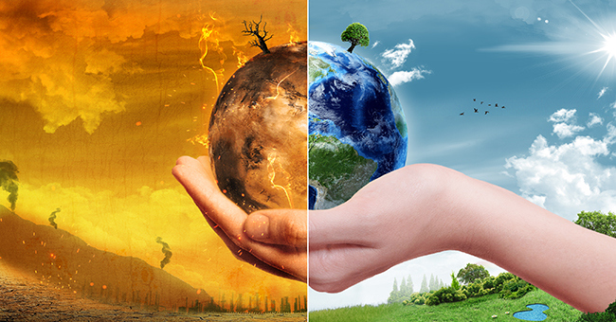

**Gaspards Week**

**Three Choirs festival**

**KS1 music and arts festival**

R.E.

What make some places special to believers?

Athletics

Daily mile

Summer walk

**School grounds**

Make a home for a dragon!!

Map a special journey through the grounds to own

Make a 3D model of the school with a key

Care for the animals and plants in school

Make a 3D model of the of the school with a key‘special place’

**Science**

**Our local environment**

**Climate change**

**Reduce, reuse recycle**

**Investigate and test ways of using less energy and water**

**Maths**

Learning to tell the time using a analogue clock

Measuring mass, capacity and temperature

Cooking dragon biscuits and making milkshakes

**English**

Dragon encyclopedia, dragon machine explanation, own story

A non- narrative poem using memories love and the beauty around us to develop resilience, and the ability to express and deal with difficult feelings in a positive way.

We are detectives!