Date | Child | Focus: Let me tell you how it works!
Thursday  10th January | Jack | Show and Tell is a whole class activity to develop a range of speaking and listening skills and behaviours.  - This term we are taking a closer look at simple mechanisms. Please could your child bring in something which moves!  - 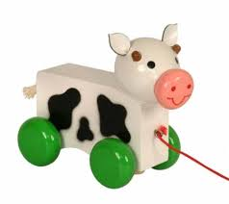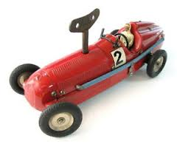  It would be great if you could talk to your child about their chosen ‘item’ to help them decide what they would like to say. It would be great if they could use words such as push, pull, axle, wheels, turn, wind up …  The following modelled language is introduced to structure sessions over the year, ie:  - I would like to show you … or I would like to tell you ….  - Who would like to ask a question?  - Who would like to comment?  - I have already answered that question. You need to listen carefully.  - That is a good question  - What can remember something I said? (Yes that is right. No that is not right.)  This activity forms part of our curriculum:  Development Matters in the Early Years Foundation Stage:  Communication and Language: Speaking  - Children express themselves effectively, showing awareness of listeners’ needs. They use past, present and future forms accurately ...  - Children begin to use more complex sentences to link thoughts (eg using and because)  - Children use a range of tenses (eg pull, pulled, pulling)  National Curriculum Year One: Speaking  Children develop the ability to:  - speak with clear diction and appropriate intonation  - choose words with precision  - organise what they say  - focus on the main point(s)  - include relevant detail  - consider the needs of their listeners.
 | Zachary
 | Skye
Thursday  17th January | Betsie
 | Jake
 | Sam
 | Lennon
Thursday  24th  January | Gracie
 | Gwen
 | Rory
 | Theo
Thursday  31st  January | Freddie
 | Nina
 | Nancy
 | Paisley
Thursday  7th  February | Evelyn
 | Evie
 | Josh G
 | Sebastian
Thursday  14th February | Josh L
 | Corey
 | James

