Milk and Honey cookies

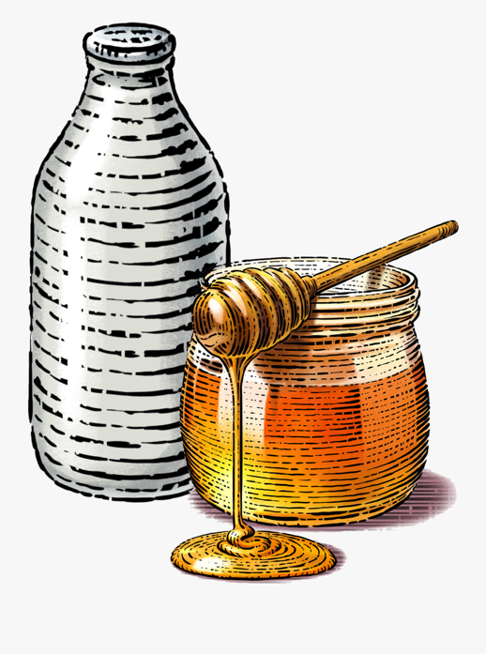
What you need for 12 biscuits:

- 75g- 3 rounded tablespoons of self-raising flour
- 75g- 7 tablespoons of porridge oats
- 75g- 3 rounded tablespoons of caster sugar
- 75g of butter
- 1 tbsp of honey
- 1 tbsp of milk

How to make them:

- Heat your oven to 180c/ gas mark 4 - grease a baking sheet or cover with baking paper.
- Sift flour into a bowl, add the oats and sugar.
- In a saucepan, gently melt the butter with the honey and milk. Add the melted mixture to the flour mixture and stir together.
- Form into biscuit shapes and bake for about 15-20 minutes until slightly brown.

