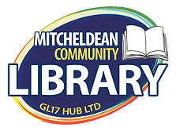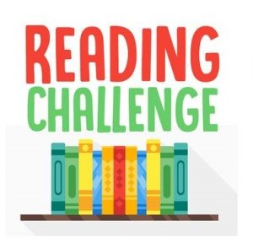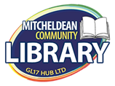

**Summer Reading Challenge**

*Hope Brook will be launching this in our assembly on TUESDAY, 19th July.*

**1st July to 10th September 2022**

**Come and visit your local library this summer!**

**Lots of new books to choose from – and some old favourites!**

|  |  |  |  |  |
| --- | --- | --- | --- | --- |
| **Cally and Jimmy: Twins in Trouble: Amazon.co.uk: Antoniades, Zoe, Kear,  Katie: 9781839130083: Books** | **Onyeka and the Academy of the Sun : Okogwu, Tolá: Amazon.co.uk: Books** | **The Breakfast Club Adventures by Marcus Rashford - 9781529076622 - Pan  Macmillan** | **The Boy in the Dress: Now a Major Musical : David Walliams, Quentin Blake,  Quentin Blake: Amazon.co.uk: Books** | **The 13-Storey Treehouse (The Treehouse Books) (The Treehouse Series, 1):  Amazon.co.uk: Andy Griffiths, Terry Denton: 9781447279785: Books** |

**Read 8 books – collect 8 stickers – choose a prize!**

***At Mitcheldean Library***