Mathematics

Numbers: reading and writing numerals, more or less, altogether, taking away
Shape, Space and Measure:
Money (1p, 2p, 5p), repeating patterns,
2D shapes, time, height

Communication and Language

I can answer questions.
I can explain my thinking
.
.
This little light of mine, I’m gonna to let it shine!
Literacy

Reading: enjoying and discussing stories, learning sounds, reading phonically spelt words, tricky words
Writing: constructing and then writing phonically spelt words and then sentences

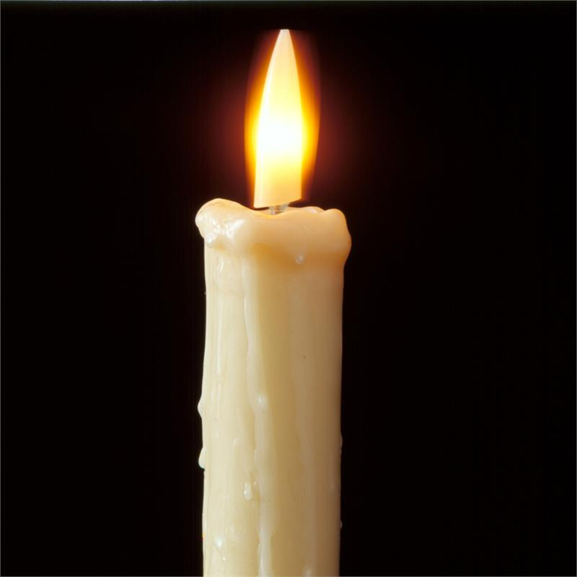
Celebrations
Expressive Arts and Design

We are printers.
They are going to melt in your mouth!
Twinkle twinkle little star

Together Time

Knowledge and
Understanding the World

Who likes the dark?
Lighting up the world!

Picture that!

Let there be light!

It’s a time to remember and a time to share.

Twit twoo!
Physical Development

PE: Repeat and combine movements which explore shape, balance, strength and stamina.
Games: catch!

Handwriting: letter and number formation just got serious

RE

Celebrations around the world

Why do Christians celebrate Christmas?

Personal, Social and Emotional Development

I show I care by looking, listening and
thinking about what has been said.
This little light of mine, I’m gonna let it shine

