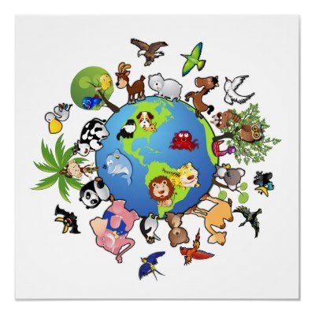

**Amazing Animals**

**The main aim of this topic is to explore the different animals in the world:**

Where they live

What they eat

What they look like and how they move

**Personal, Social and Emotional Development:** We will be building our concentration and resilience. Continuing to develop self-regulation skills.

Knowing how to keep ourselves safe and how our bodies grow and change.

**Expressive Arts and Design:** dress up as animals.

Study of Matisse ‘The Snail’ picture- make a response in collage and printing.

Animal printing. Making animals using a range of media.

**As musicians** explore various percussion instruments to accompany animal songs

**Maths:**  Building numbers and counting patterns beyond 10. Adding more and taking away. Spatial reasoning. Doubling, sharing and grouping, even and odd. Deepening understanding of pattern and relationships.

**Communication and Language:** Building confidence to ask for clarification when unsure during group work. Knowing how to explain our thinking, imagine possibilities and use a range of constructive vocabulary when playing to express needs and thoughts. Discuss new words and meanings.

**Literacy:** Sharing fiction and non-fiction books about animals.

Labelling animals. Story sequencing and caption writing. Writing clues to guess what animal it is.

Writing animal descriptions to include adjectives.

Consolidating existing phonic knowledge and learning to read and spell longer words containing adjacent consonants. We will also be learning the phase 4 tricky words.

**Understanding the World:** we will be exploring the local environment, observing animals and drawing pictures. We will be noticing similarities and differences between animals that live in the UK and other countries we read about. Learning through close observation how caterpillars change into butterflies and tadpoles change into frogs.

**This terms values** are Creativity and Trust.

**Physical development- Fine Motor Skills:** manipulating different dough’s and clay to create animals. Building animals using lego. Developing cutting, threading and construction skills making animal masks and models using recycled materials.

**Gross Motor Skills:** doing the animal bop-moving like animals, creating dance routines and responding to music through dance. Throwing a small ball, using a bat and racket. Practicing our running, jumping and movement skills in preparation for sports day.