Hope Brook C of E Primary School Remote Learning Plan

In September 2020, all our classes returned to full-time education following the Covid 19 closure in March. Although we hope that the majority of our children will now have an uninterrupted experience, there is the possibility that an individual child, a class bubble, or indeed the whole school, will need to self-isolate for a period of time. We have therefore put in place a plan for remote learning so that all children can continue with their education. This meets the expectations set out in the DfE guidance ‘Remote Education Support’ https://www.gov.uk/guidance/remote-education-during-coronavirus-covid-19
In order to ensure that learning is continued, irrespective of lockdown or self-isolation, Hope Brook C of E Primary School has developed the following plan. This plan offers remote learning opportunities whilst also acknowledging that some households have limited access to devices and might require hard-copies of work and resources. Parents are reminded to make the school aware of any barriers to accessing remote learning
This plan will be applied in the following instances:
1. An individual is self-isolating because of a positive test within the household;
2. A whole bubble or cohort is self-isolating because of an outbreak of coronavirus
The plan complies with the expectations and principles outlined in the DFE document Guidance for Full Opening of Schools.
Software and online platforms
School will:
Within all plans, teachers will set appropriate work in line with our current curriculum, primarily supplemented by a range of resources provided by Oak National Academy, White Rose Maths and Active Learn.
Children will remain in contact with their Class teacher through the ESchools platform (to share successes and communications). Teachers and parents will be able to message one another to share information and offer support.
Oak National Academy has been selected to support remote learning for a number of reasons. The Oak Academy lessons are in-line with our teaching ethos – they encourage the use of retrieval practice and explicit teaching with high quality modelling. The online lessons are free to all and offer a recorded taught session so that the children can access physical teaching from a teacher and then access work relating to that lesson within the same website. There are also lessons specifically aimed at children with SEND.
White Rose Maths, Active Learn resources and TT Rockstars will be used to support the teaching of maths, as they are matched to our current maths curriculum model. Children are very used to seeing these resources.
In the event of any form of isolation and loss of learning caused by Coronavirus, parents should understand that engagement in home learning is compulsory, as is the expectation that Hope Brook C of E Primary School makes that provision available and accessible to all. However, if children themselves are too ill to attend then they should not be expected to engage in home learning.
In preparation for home-learning, parents and children have received logins and passwords for various resources:
- ESchools
- TT Rockstars
- Purple Mash
- Active Learn
- Lexia
- Oxford Owls (KS1)
- Love4Reading
- Tapestry (YR)

Initial Remote Learning Pack
If a child is isolated from school i.e. the child is sent home from school to either receive a test or self-isolate as someone in the household is being tested, a pack of work might be provided. This will mean the children will have an immediate opportunity to continue their learning. The work packs will be basic skills work that would be relevant at any stage of the year i.e. arithmetic, spelling, reading, writing and handwriting. This will enable the teacher to have some time to prepare appropriate resources for your child’s needs. Within a couple of days, the remote learning materials will be available for the child. The material will be accessed from the children’s Homework pages on the ESchools platform.

Please note – Remote Learning materials will be provided for children ‘where it would be unlawful, or contrary to guidance issued by one of the public authorities for a pupil to travel to or attend their school.’

Pupils may need to isolate because:
- Someone in their household is symptomatic, tests positive or is awaiting a test result
- A whole bubble/cohort of children is isolating because of an outbreak of coronavirus

Ongoing support from school | Parents will | Safeguarding / SEND
Using the ESchools platform, the Class teacher will upload worksheets daily.  The teacher will decide which materials are most appropriate for the individual child.  If teaching input is required for core lessons, the teacher will direct the parent to a relevant Oak National Academy or White Rose taught session.  In the event of teachers becoming ill, support staff will ensure work is available on the ESchools platform or Tapestry (YR). | Provide opportunities for the children to access the ESchools platform  Enable children to access electronic devices - desk-tops/laptops/tablets are ideal. If there is an issue with providing these, parents should inform the school  Ensure that all work related to the day’s sessions is uploaded onto ESchools platform by 3pm  Phone school in the usual way if their child is ill  Be respectful to teachers when interacting via the ESchools platform and be aware that queries will only be answered during normal school hours | School office to contact parents to ensure a test has been taken and to make sure that parents know to communicate test results to admin@hopebrook.gloucs.sch.uk  If child is entitled to FSM, school to ensure food made available through Caterlink.  If child is vulnerable in any way, the DSL will ensure that appropriate agencies are notified and arrange for regular well-being checks (ie. Weekly) via a phone call from the SENCo or the FSW where appropriate. (This will be documented on CPOMS).  If a child does not engage, the Class teacher / Family Support worker will call the parents to discuss obstacles and support.  Where children would normally receive additional support from SEND agencies, the SENDCo will make arrangements for those to continue via zoom as long as the agencies engage.
KS1 & KS2
The daily work will include at least a maths and English task for each day. It will also include at least one other curriculum area. Where possible work will be aligned to the curriculum work being carried out at school.
The teaching content will be provided to the children through age appropriate video content from the Oak National Academy website. This provides the equivalent of approximately 3 hours teaching material per day. This material is easy to use. No logins or passwords are required, and you can access the lessons on any device.
The pictures below provide a snapshot of what the pages look like on the Oak national academy pages.
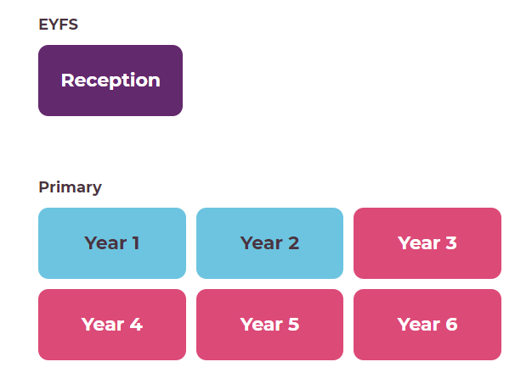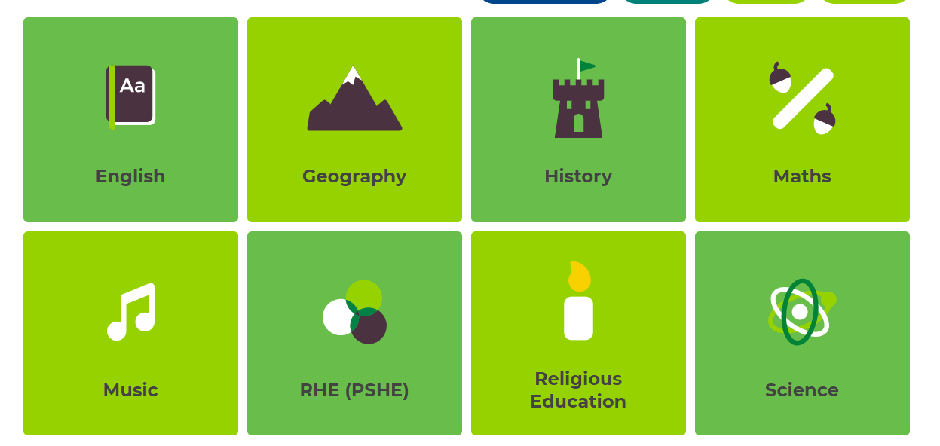
https://classroom.thenational.academy/

When using the Oak National Academy materials, the teachers will direct pupils to appropriate resources. Other materials/resources will be uploaded to ESchools, and where possible web-links to appropriate support materials will be provided.
Work completed should be uploaded to the ESchools platform by 3pm each day. Teachers can then review the work completed and ensure that misconceptions are addressed before the next lesson.

Safeguarding: Please refer to the Child Protection Policy
Data protection: When accessing personal data, all staff members will only use their official school email account and connect to the school network using their school laptop only.
Sharing personal data: Staff members are unlikely to need to collect and/or share personal data. However, if it does become necessary, staff are reminded to collect and/or share as little personal data as possible online. All data collection will be compliant with GDPR guidelines.
Keeping devices secure: All staff will take appropriate steps to ensure their devices remain secure. Computers should be locked if left inactive for a period of time. Operating systems must be up to date – always install the latest updates.
Monitoring arrangements: This policy will be reviewed by the SLT as and when updates to home learning are provided by the government.

