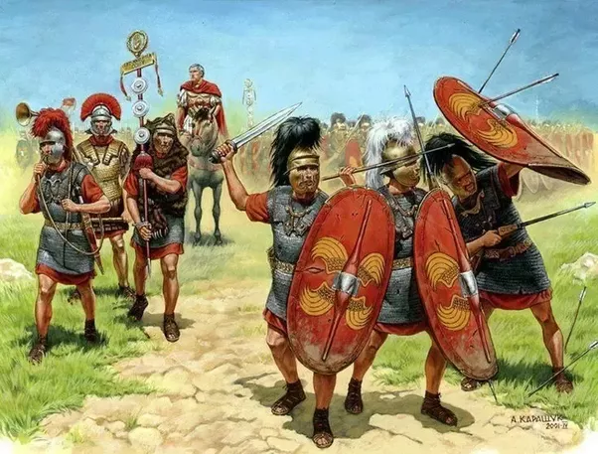Wait

**Geography:**

* Using maps to identify what countries the Romans invaded.
* Identify the Route the Romans took to invade England and travel throughout.
* Why did they choose these places?

**Art: (Mosaics)**

**–** Comparing Ancient Roman and modern mosaics and creating their own.

**DT:**

Following instructions to make Roman Bread. Comparing this to Bread today.

**History:**

* How Roman armies were used.
* Resistance – focusing on the example of Boudicca.
* Hadrian’s Wall.
* Impact upon life in Britain: technology, food, buildings, roads (link with Gloucestershire.
* Leisure activities.

**French:**

* Greetings
* Introducing yourself

**Music**

* Playing notes on the Glockenspiel

**Roman Invaders**

**English:**

We will be writing a range of short and long pieces of writing based on the books ‘Lights on Cotton Rock’ and ‘Black Dog’ as well as a Disney Pixar short film clip. These will include descriptions, stories, recounts, letters and adverts.

**Non-Chronological report:**

On what the Ancient Romans did for leisure.

**Science:**

**Plants & Forces (topics missed due to school closure for some)**

**–** What plants need to survive and grow

- Identify the parts of flowering plants and their functions.

- Life cycle of flowering plants, including pollination.

- Know that magnets have two poles and that they can attarct and repel.

- Magnetic materials.

- Friction and how it impacts moving objects.

**RE:**

**What do Christians learn from the creation story?**

* Know, recall and reflect on the story of creation.
* Identify ways in which Christians try to look after God’s world.
* Identify messages from the Story of Adam and Eve’s temptation.
* Know how the 10 Commandments help Christians live a respectful life.

**Computing:**

**We are Network Engineers**

- know how networks are set up and what they consist of.

Understand how technology within a network can communicate.