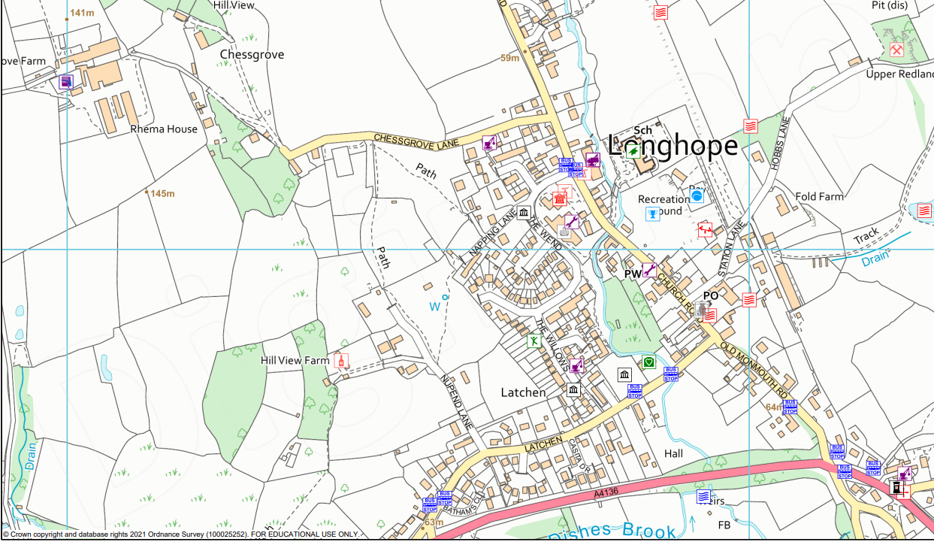

**CPHSE:** Our focus for this term is things we can look after.

**English:**

* Letters and postcards.
* Fantasy story writing.
* Poetry.

**Maths:**

* Consolidating place value.
* Recognising and counting coins.
* Reading the time, writing the time and comparing time.
* Representing statistics using pictograms and block graphs.

**Science:** We will be doing a range of activities which will develop knowledge of environmental issues and understanding of the simple changes we can make to live more sustainable lives.

**PE**: We will be continuing with our theme of athletics. The children will

learn the basic movements associated with athletics. They will explore the principles of jumping, running and throwing in a safe environment pushing themselves to do better each time.

**ICT:** The children will be developing their skills to create, organise, store, manipulate and retrieve digital content through the creation of their own digital story book.

**RE:** Our question for this term will be: what makes some places sacred to believers?

**Geography:** This term our focus will be the local area. We will be locating where we live on a map, comparing our routes to school and identifying the human and physical features of the locality. We will be developing our map reading skills, creating our own maps,

planning a route and going on a walk.

**Values:** We will be focusing on a value each half term, reflecting on its different meanings. Our focus for this term will be perseverance.

Wrens class

Curriculum Overview

Summer 2

Where I live