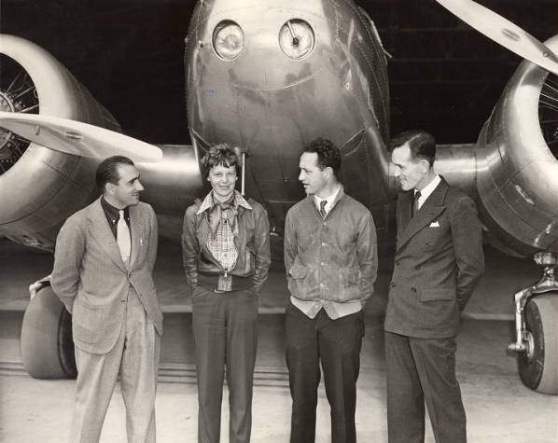

**Outdoor learning**

**Creative aerial map**

**Archaeological dig**

**Using wood to make objects**

**Visit to Rococco Gardens –Woodland trail and gardens**

**snowdrop poems and maths**

Cook macaroni cheese

**Religious Education**

**Who is Muslim and how do they live?**

**Personal Development**

**Friendship and difference**

**Physical Education**

**Net and wall games**

**Gymnastics**