**Physical Development:** object control skills

**Fine Motor Development** - daily access to resources, activities and opportunities provided through continuous provision e.g. threading, play dough, building and creating, colouring, puzzles etc

Develop control when using scissors and other tools.

Talk about healthy practices.

Sunshine and Sunflowers

**Communication and language:**

* Listen to and understand questions.
* Use new knowledge and vocabulary during play.
* Use talk to help work out problems and organise thinking and activities, and to explain how things work and why they might happen.
* Describe an event in the correct order and including some details.
* Express ideas about feelings and experiences.
* Articulate ideas in sentences
* Show that they can use language to reason and persuade E.g. “Can I go outside because it’s stopped raining?”

**Personal, Social and Emotional Development**:

* Initiate an apology where appropriate.
* Understand rules linked to road safety.
* Follow directions with 3 parts.
* Be considerate to the needs of others, beginning to respect a different point of view and work together in collaboration.
* Know it is important for all of us to keep safe when using and transporting tools, equipment, and resources

**Corum curriculum: Being My Best**

* Feel resilient and confident in our learning.
* Name and discuss different types of feelings and emotions.
* Learn and use strategies or skills in approaching challenges.
* Understand that they we make healthy choices.
* Name and recognise how healthy choices can keep us well.

**Literacy-**

* Continue to experience and respond to different types of books.
* Use vocabulary that is influenced by experience of books.
* Build words using known letter-sound correspondences in own writing.
* Orally compose a sentence/caption and hold it in memory before attempting to write it.
* Learn how to write basic sentences (Capital letters, finger spaces and full stops)
* Spell some Common Exception Words correctly.

**Phonics:** Continue to learn single graphemes, digraphs and trigraphs. Recognising the sounds and building words containing the letters: s, a, t, p, i, n, m, d, g, o, c, k, e, u, r h b f ff l ll ss , v, w, x, y, z, qu, sh, ch, th, ng, ai, ee, igh, oa, oo, ar, or, ur, ow, oi, ear, air, ure

Recognising and reading the words I, to, no, go, the, we, me, be, he, she, was, my, you, they, all, are and her.

Blending of words with adjacent consonants that contain graphemes taught in Phase 2.

**Read:** Learn phase 4 Common Exception words: said, like, so, some, were, there, little, one, when, out and what.

**Write:** he, she, we, me, be, was, you, they, all, are, my and her

**Maths:**

* make 10- know and work out bonds to 10.
* Doubling.
* 3D shapes.
* Patterns.
* Learning about numbers to 20 and beyond.

Sunshine and Sunflowers

**Expressive Art and Design:** designing and making a fruit smoothie.

* Exploring fruits and vegetables and the differences between them.
* Using tools safely including knives to prepare ingredients.

**Role play:**

* Garden centre and café.
* Build on storylines in play.

****Our value this term will be **forgiveness.** This links with our schools behavior policy, in particular our use of restorative practice to help children replace antisocial behaviours with prosocial behaviors. Apologies will be made to those affected by the behaviour It is important that all of our children know that, when they have reflected on their actions and put things right, they will be forgiven and that every day is a new start.

**Some ways we may demonstrate this are:** throwing away hate, praying to God and solving conflicts between people. Forgiving someone can be hard, but not forgiving and holding onto grudges can be worse. Saying sorry can solve a lot of problems but forgiving someone can fix a lot of pain.

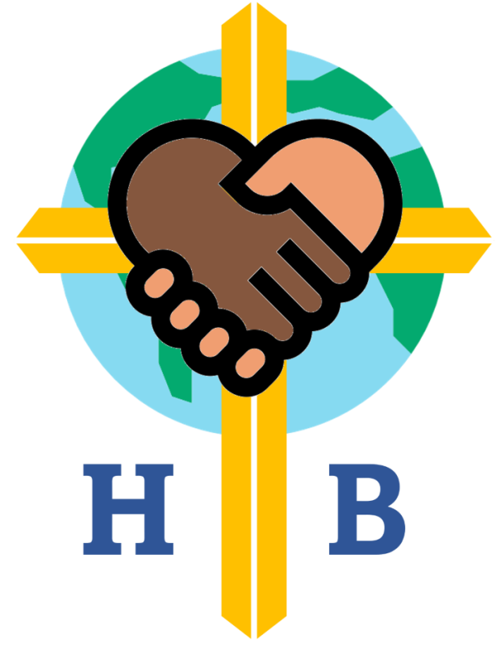 **Vision and spirituality links:**

**Grow in Gods love to bring hope to the world**

**Ows-** think about those people experiencing hard times and reflect on how we can help them.

**Wows-**new growth in nature.

**Nows-** appreciate our wonderful world and help to care for it.

**RE: Creation- Why is the word God so important to Christians?**

* Talk about how and when Christians like to thank God for his creation and giving.
* Know God is the name Christians use for who they believe created the earth and universe.
* Know that Christians believe God made our wonderful world and that we should look after it.
* Talk about ways Christians give thanks to God.

**Understanding The World:**

* Begin to observe and talk about living things in the local environment.
* Talk about different habitats.
* Begin to name and group plants and trees according to their observable features
* Notice and observe patterns of weather in summer and winter
* Name and describe basic features of plants and trees
* Observe, record and talk about materials and living things
* Describe some ways in which plants and animals should be cared for in order to survive