Collective Worship Theme: Thankfulness
Robins Class – Year 2019-20 AT2– Celebrations! - Weekly Reminders

Week 1  WB 4 11 19  Focus: Fireworks | Monday: Games (Please ensure your child has the appropriate named items in their PE kit.)  Wednesday: NO ACTIVE LEARNING AFTERNOON  Thursday: Robins Class Assembly  Show and Tell  Friday: PE, Spellings for Year 1s, Reading Tree (bead for reading 3 times in the week)  2.30pm Together Time
Week 2  WB 11 11 19  Focus: Diwali | Monday: Remembrance Service  Games  Wednesday: Active Learning Afternoon (It would be great if your child packs their bag with you.)  Thursday: Show and Tell  Friday: PE, Spellings for Year 1s, Reading Tree (bead for reading 3 times in the week)  NO TOGETHER TIME
Week 3  WB 18 11 19  Focus: Birthdays | Monday: Games  Tuesday: ‘Role Play’ a Birthday Party (Children will need party clothes in a named plastic bag)  Wednesday: Active Learning Afternoon  Thursday: Show and Tell  Friday: PE Spellings for Year 1s, Reading Tree (bead for reading 3 times in the week)  2.30pm Together Time
Week 4  WB 25 11 19  Focus:  Christenings | Monday: Games  Tuesday: We will be taking a closer look at Christenings. It would be great if children could  bring in any photos or artefacts of their Christening experiences. (They will be returned the same day.)  Wednesday: Active Learning Afternoon – Bikes and helmets  Thursday: Show and Tell  Friday: Spellings for Year 1s, PE, Reading Tree (bead for reading 3 times in the week)  Christmas Making Afternoon  NO TOGETHER TIME
Week 5  WB 2 12 19  Focus: Christmas  (Nativity) | Monday: Children to bring in their Nativity Costume (Please put in a named plastic bag.)  Games  Wednesday: Experience Christmas at Church  NO ACTIVE LEARNING AFTERNOON  Thursday: Show and Tell  Friday: Spellings for Year 1s, PE, Reading Tree (bead for reading 3 times in the week)  2.30pm Together Time
Week 6  WB 9 12 19  Focus:  Christmas  (Nativity) | Monday: Games  Wednesday: Nativity Performance  NO ACTIVE LEARNING AFTERNOON  Thursday: Nativity Performance  Friday: Spellings for Year 1s, Reading Tree (bead for reading 3 times in the week)  Robins and Woodpeckers - Theatre visit  Tricky Word Competition (Prize for fastest reader and ‘the best learner’. Please comment in the  Reading Journals to help us know who is working hard to learn the Tricky Words.)  NO TOGETHER TIME
Week 7  WB 16 12 19  Focus:  Christmas  (Father Christmas) | Monday: Games  Wednesday; Active Learning Afternoon – Tidy Outside Area  Thursday: Post letters to Father Christmas  Christmas Dinner, followed by Christmas Party Time  (Children will need party clothes in a named plastic bag. Please no ‘high heels’.)  Friday: School Christmas Event organised by School Council  No spellings. Reading Tree (bead for reading 3 times in the week)  NO TOGETHER TIME

Pease be aware that the nature of school life may mean dates and times alter as the term evolves.
Please regularly check your child’s Book Bag and the Parent’s Notice Board on Robins’ Class window for any changes.

Wanted:
Plastic lids of all shapes and sizes
Boxes (small and medium)
Unwanted cutlery and utensils for the Mud Kitchen
Interesting bits and pieces for Junk Modelling
Large plant pots
Dressing up clothes
Bed sheets for den making
Clean pipes left over from any plumbing activities!
Large plastic sheeting such as ground sheets
Wooden solid shapes

Together Time –Fridays at 2.30pm

During Together Time we will split into small groups of children and one adult to enjoy games, tasks and share stories or information books. The activities will be provided but if you have a book you would love to read with a group, then please let us know. Grandparents are very welcome.

Date | I would love to join Robins’ Together Time.
 | Child’s Name |  | Adult’s Name and relationship to child
Week 1  8.11.19  (6 groups) | 1
 | 2
 | 3
 | 4
 | 5
 | 6
Week 3  22.11.19  (6 groups) | 1
 | 2
 | 3
 | 4
 | 5
 | 6
Week 5  6.12.19  (6 groups) | 1
 | 2
 | 3
 | 4
 | 5
 | 6

If your name is on this list, please let us know if you are unable to attend, so we can adjust the groups and avoid any children becoming upset.
“Mum, it’s
your turn.”
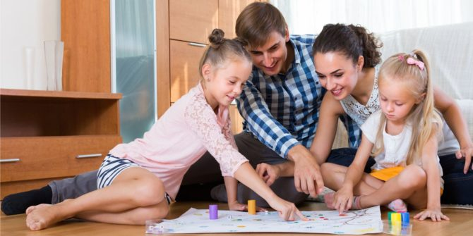
a

“I’m interested, tell me more.”
Together Time,
Make It Count!

Dad, do
you think
that’s true?”

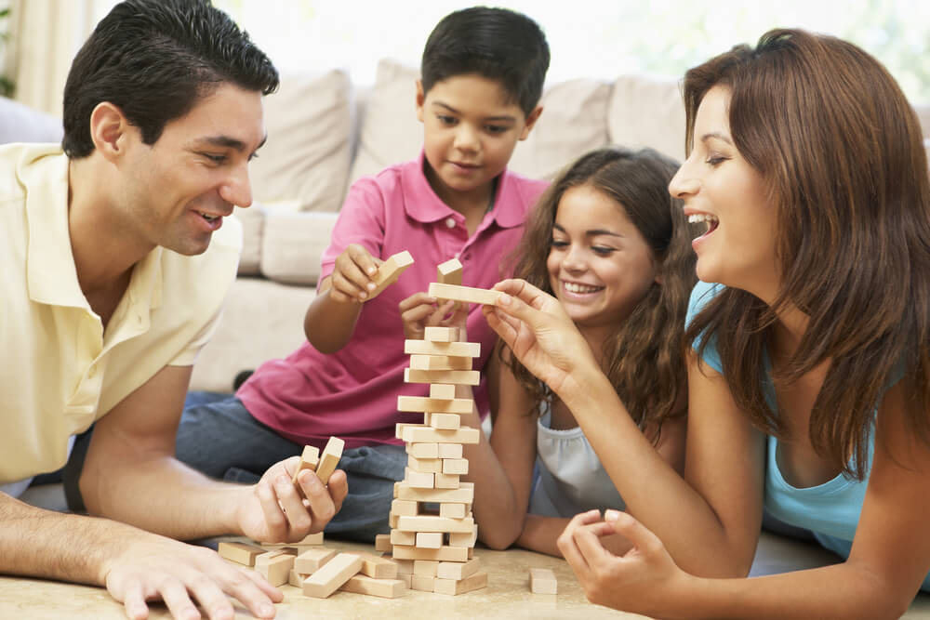

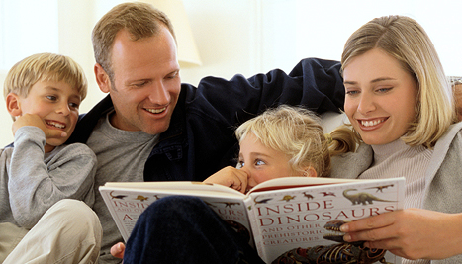
It’s tricky,
take care.”

